Software Requirements Specification

for

Hawkere

**Version 1.0 approved**

**Prepared by Prem Adithya Suresh**

**PilsnerUrquell**

**4 April 2019**

**Table of Contents**

1. Introduction 4

1.1 Purpose 4

1.2 Document Conventions 4

1.3 Intended Audience and Reading Suggestions 4

1.4 Product Scope 4

1.5 References 4

2. Overall Description 4

2.1 Product Perspective 4

2.2 Product Functions 5

2.3 User Classes and Characteristics 5

2.4 Operating Environment 5

2.5 Design and Implementation Constraints 6

2.6 User Documentation 6

2.7 Assumptions and Dependencies 6

3. External Interface Requirements 6

3.1 User Interfaces 6

3.1.1 Confirmation Dialogs 6

3.1.2 Informative Toasts 6

3.1.3 Buttons 7

3.1.4 Action Bar 7

3.1.5 Menu Option 7

3.1.6 Sliding Bottom Sheet 8

3.1.7 CardView 9

3.3 Communications Interfaces 9

4. System Features 10

4.1 Log In 10

4.1.1 Description and Priority 10

4.1.2 Stimulus/Response Sequences 10

4.1.3 Functional Requirements 10

4.2 Fetch and Display Hawker Centres 10

4.2.1 Description and Priority 10

4.2.2 Stimulus/Response Sequences 10

4.2.3 Functional Requirements 10

4.3 Display Information of a Hawker Centre 11

4.3.1 Description and Priority 11

4.3.2 Stimulus/Response Sequences 11

4.3.3 Functional Requirements 11

4.4 Submit Rating, Review or Photos 12

4.4.1 Description and Priority 12

4.4.2 Stimulus/Response Sequences 12

4.4.3 Functional Requirements 12

4.5 Share Hawker Centre Via Other Apps 13

4.5.1 Description and Priority 13

4.5.2 Stimulus/Response Sequences 13

4.5.3 Functional Requirements 13

5. Other Nonfunctional Requirements 13

5.1 Performance Requirements 13

5.2 Usability Requirements 13

5.3 Reliability Requirements 14

5.4 Supportability Requirements 14

5.5 Security Requirements 14

Appendix A: Glossary 14

**Revision History**

|  |  |  |  |
| --- | --- | --- | --- |
| **Name** | **Date** | **Reason For Changes** | **Version** |
| Prem Adithya Suresh | 4 Apr | Created the draft | 0.1 |
| Prem Adithya Suresh | 7 Apr | Completed the documentation | 1.0 |

# 

# Introduction

## Purpose

This document presents a detailed description of the Hawkere android application. It defines the system boundaries, interface and communications with external APIs and applications.

## Intended Audience and Reading Suggestions

This document is intended for developers, project managers, users and testers. The group “users” refers to anyone who would potential use the app to find a nearby hawker centre as a cheaper food option.

## Product Scope

“Hawkere” is an android application designed to assist users in finding hawker centres near them and provide detailed information of the hawker centres. The information provided includes distance of hawker centres from the user’s location, name, description, address, opening hours, number of stalls, detailed ratings and reviews by the other users.

## References

The design components of the application follow the material design guidelines closely published by Google here: <https://material.io/design/>

The user interface design follows Ben Schneiderman's eight golden rules available here: <https://faculty.washington.edu/jtenenbg/courses/360/f04/sessions/schneidermanGoldenRules.html>

# Overall Description

## Product Perspective

“Hawkere” is meant to bridge the gap between Google Maps and Singapore Govenment’s datasets. Google maps does not have detailed and updated information of the various hawker centres around Singapore. The dataset by the Singapore Government contains detailed and updated information of the various hawker centres. However, this dataset does not contain operating hours for all of these hawker centres. Fortunately, Google Maps contains operating hour information submitted by users for many hawker centres in Singapore. Hence, Hawkere uses the data from Google Maps and the dataset to provide a unified application with all the essential information paired with additional features to provide users with an enhanced user experience.

## Product Functions

The major functions of the application are:

Searching for hawker centres

* Finding hawker centres nearby
* Viewing details of a selected hawker centre
* Submit ratings/review for the hawker centres
* Uploading photos of the hawker centres
* Share the hawker centre with others
* Login with a Google account / Logout

## User Classes and Characteristics

Novice users - This class of users will use the app to briefly know the hawker centres near them and will not post reviews or photos of hawker centres. This class of users are also not expected to use the app very often.

Intermittent users - This class of users will use the app to find out detailed information about hawker centres near them and may even search for specific hawker centres in mind. This class of users are expected to post reviews and photos once in a while and use the app much more often than the novice class of users.

Advanced users - This class of users know the app well and will use all the basic search and navigational features very comfortably. These users are also expected to be the main contributors to reviews and photos of the hawker centres. Lastly, this class of users are expected to use the app the most among all three classes of users.

The app will have to be well designed to satisfy the needs of the intermittent and advanced class of users.

## Operating Environment

The application will run on phones with Android 6.0 and above installed. The app will have to parse the dataset containing hawker centre data locally, communicate with the Google Maps API for the opening hours information and the app database which resides on Google Cloud Firestore for ratings and photos.

## Design and Implementation Constraints

The app will have to rely on Google login for access control. A custom access control system is not required at this stage as the login is only used to identify the ownership of users’ reviews and photos. A custom access control system can be considered along with other app expansions at a later stage.

## User Documentation

A simple guiding tutorial will be added to the app at a later stage

## Assumptions and Dependencies

It is assumed the users using the application are connected to the internet

# External Interface Requirements

## User Interfaces

Shneiderman’s eight golden rules of user interface design and Google’s material design guidelines were applied to the design of the application.

### Confirmation Dialogs

The confirmation dialogs in the app follow this design where the title and message of the dialog are changed accordingly.

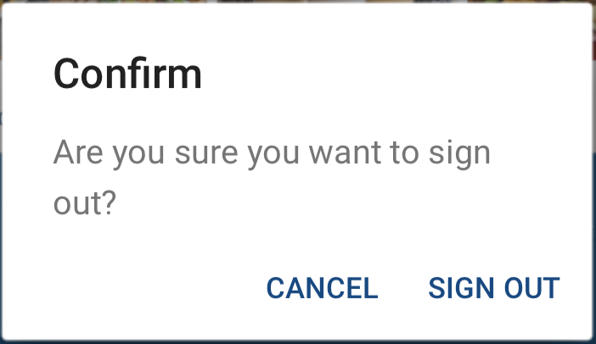

### Informative Toasts

The informative toasts in the app follow this design and they appear at the bottom of the screen with an appropriate icon, message and colour.





### Buttons

All buttons in the app follow this design and color. On light backgrounds, the solid color button is used. On dark backgrounds, the button with no fill color is used.



### Action Bar

The action bar stays consistent on all screens following these designs. This follows one of the golden rules of consistency.





### Menu Option

The 3 dot menu icon appears on the action bar, which when expanded shows more options. This menu follows this design which is based on Google’s material design guidelines.



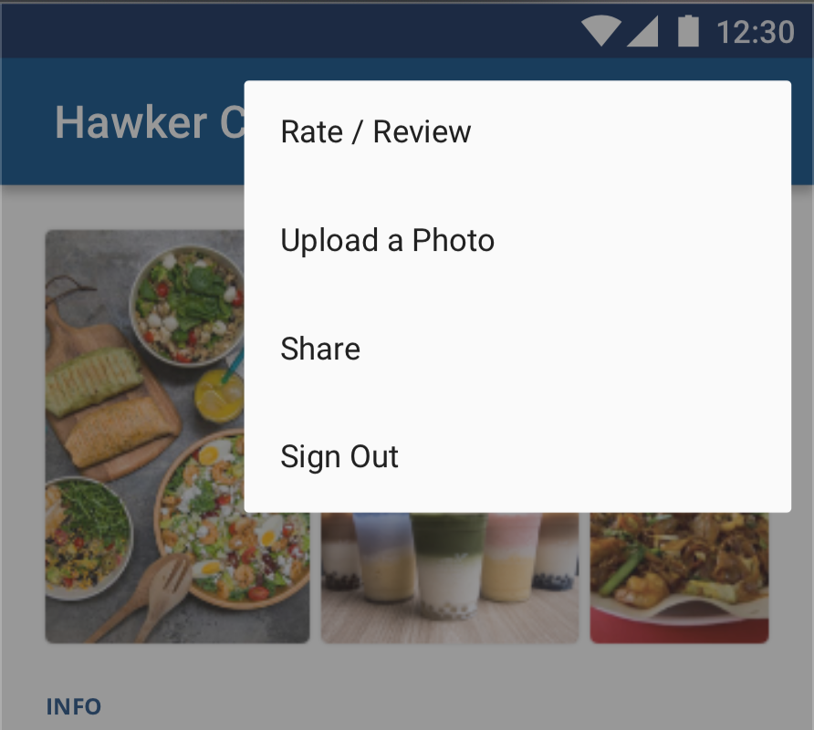

### Sliding Bottom Sheet

A custom sliding bottom sheet was designed, inspired from similar applications on the market such as Google Maps, Gojek and Grab. There is no open source library present for such an implementation and hence a custom approach was adopted.

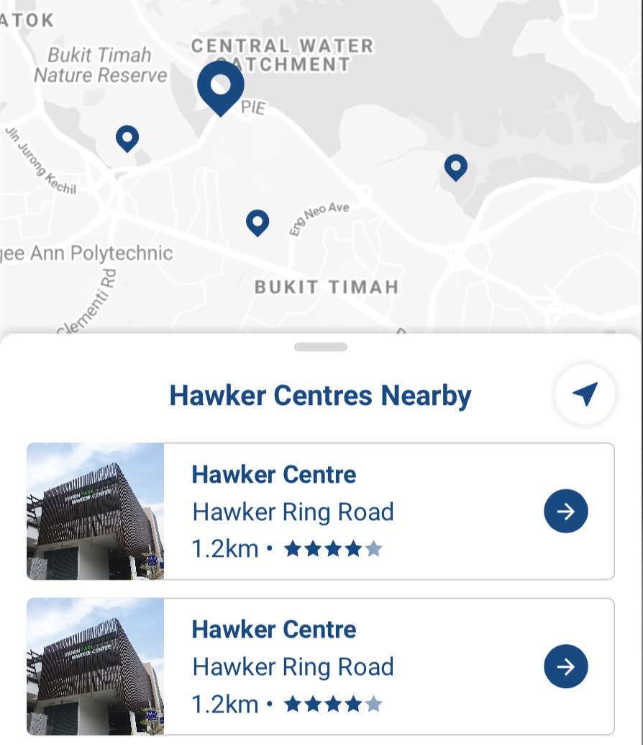



### CardView

The app uses CardViews as a primary container of information according to Google’s material design guidelines. It makes the design modular and allows for more information to be added to the pages with the use of more CardViews.

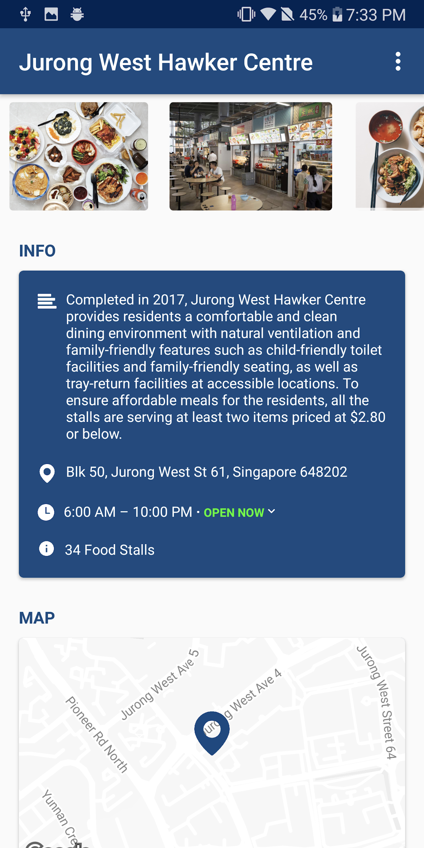

* 1. **Adherenece to the Golden Rules**

Ben Schneiderman’s golden rules are listed below and the adherence of the application design to these rules are explained.

### Strive for Consistency

Similar sequences of actions should have similar terminology in prompts, actions, menu help and commands.  The application design uses consistent action bars, buttons, and fonts across the different pages of the app. The app also uses similar components to other mapping and navigational apps for consistency.

### Cater to Universal Usability

The application has simple features and the layout is designed intuitively. Hence, the app will not have a steep learning curve and most age groups of users will be able to use the app easily.

### Offer informative feedback

The UI of the app informs users on the various actions performed with a feedback on the result of the action. Giving the user feedback lets the user be aware of the state of the app at all times relative to the user’s interaction with it.

### Design dialog to yield closure

Whenever user’s perform risky actions, the users are presented with dialogs to confirm or cancel the action. This will easy the user’s anxiety as it assures users that they will not be able to take an unwanted action accidentally. Moreover, login sequences are presented with a sequence of dialogs to provide users with a sense of accomplishment when they login successfully, thereby enhancing the user experience.

### Permit easy reversal of actions

The app supports the native back button in the bottom navigation bar where users can go back from any page to the previous page within the app at any time. This allows users to reverse their actions whenever they want without having a lasting effect.

### Support internal locus of control

The app give the users control by not forcing them to log in to use the app. Users only have to login when they are about to submit a review, rating or a photo. Moreover, users are able to log out whenever they want, after logging into the app. Lastly, users are also able to edit their ratings and reviews after they have submitted one giving them more control over their submitted content.

### Reduce short-term memory

The app has a top down information structure where more details are shown as users navigate deeper into the app. Relevant information and related actions are displayed on separate screens. This way, too much information is not shown on a single page and too many actions are not permitted from any one page reducing the need for users to remember too many things at once.

### Prevent error

The user interface is designed to be robust and user friendly and hence it naturally avoids big logic flaws which could lead to errors. Moreover the application is programmed to handle networking errors graciously therefore preventing catastrophic crashes.

* 1. **Software Interfaces**

The following APIs are used by the application:

* Google Places API - To fetch opening hours
* Singapore Government Dataset - To fetch hawker centre details
* App Database on Google Cloud FireStore - To fetch ratings, reviews and photos
* Google Login API - To fetch user info to tie with reviews, ratings and photos

## Communications Interfaces

HTTPS protocol will be used to communicate with the APIs and the development platform (Android Studio) has libraries with native support for HTTPS.

# System Features

## Log In

### Description and Priority

Users who intend to submit ratings, reviews or photos have to log in with their Google accounts first. This feature is of medium priority as not everyone will submit content to the app.

### Stimulus/Response Sequences

1. User selects to submit rating, review or photo for a hawker centre from the details page.
2. App checks if the user is already logged in.
3. If the user is not logged in, a prompt to login with a google account is shown
4. User logs in with their google account

### Functional Requirements

1. The app must allow the user to login with their Google account
   1. After logging in, the app must allow users to sign out whenever they want

## Fetch and Display Hawker Centres

### Description and Priority

The app will fetch the user’s location and show the users hawker centers nearby sorted by distance. The app should also allow users to search for specific hawker centres. This feature is of high priority as it is one of the core functionalities of the app

### Stimulus/Response Sequences

1. User opens the app for the first time.
2. The app requests for location services permission from the user
3. If user grants the permissions, hawker centres nearby will be fetched and shown sorted by distance
4. If the user does not grant the permissions, all hawker centres will be shown sorted in an alphabetical order

### Functional Requirements

1. The app must request for permission to access the user’s location
   1. If permission is granted by the user, the app must show a map of all hawker centers within a 5km radius of the user’s location
      1. The hawker centres must be listed in an ascending order of distance from the user’s location
   2. If permission is not granted by the user, the app must show a map of all hawker centres in Singapore
      1. The hawker centres must be listed in ascending alphabetical order
2. The app must give users an internal locus of control over the hawker centres shown
   1. Users must be able to search for specific hawker centres with:
      1. The name of the hawker centre
      2. The address of the hawker centre
   2. Users must be able to drag the map manually to look at hawker centres around Singapore
   3. Users must be able to scroll through the list of hawker centres manually

## Display Information of a Hawker Centre

### Description and Priority

The app should display all specific details of the selected hawker center, including reviews, ratings and photos submitted by other users. This is of high priority as this is a core feature of the app.

### Stimulus/Response Sequences

1. User selects a hawker centre from the map/list
2. The app shows detailed information of that hawker centre

### Functional Requirements

1. The app must show detailed information of a hawker centre when users tap into any of the hawker centres shown
   1. The app must display up to 4 most recent user uploaded photos of the hawker centre if available
      1. When the user taps on the photos section, the app must display all available user uploaded photos in ascending order of age of photos
         1. Every photo displayed must display the name and avatar of the uploader
   2. The app must display a short description of the hawker centre
   3. The app must display the full address of the hawker centre
   4. The app must display the operating hours of the hawker centre
      1. The app must display if the hawker centre is open, relative to the current time of the user’s phone
      2. When a user taps on the operating hours, the app must display the operating hours of the hawker centre everyday from Monday to Sunday
   5. The app must display the total number of food stalls at the hawker centre
   6. The app must display a snippet of the location of the hawker centre on the map
   7. The app must display a breakdown of the user submitted ratings consisting of the hygiene, seating variety and quality of the food
   8. The app must display the latest user submitted review of the hawker centre if available
      1. When the user taps on “see all”, the app must display all available user reviews in ascending order of age of review
      2. Every review must be displayed with the user’s name, profile picture and their overall rating

## Submit Rating, Review or Photos

### Description and Priority

The app should allow users to upload ratings, reviews and photos of the various hawker centers. This is of medium priority as not all users will be submitting content to the app.

### Stimulus/Response Sequences

1. User selects a hawker centre
2. User opens the menu
3. User selects the appropriate option
4. User uploads rating/review/photo

### Functional Requirements

1. The app must allow users to submit a rating out of five stars on the hygiene, seating, variety and food quality of a hawker centre.
   1. The app must allow users to submit an optional review along with the ratings.
2. The app must allow users to upload a maximum of 1 photo at a time of a hawker centre.
   1. The app must allow users to take a photo for upload.
      1. After taking a photo, the app must allow the user to retake the photo if the user wants to
   2. The app must allow users to choose a photo from the gallery for upload.

## Share Hawker Centre Via Other Apps

### Description and Priority

The app should allow users to share an intent link of the hawker centre to other users of the app.

### Stimulus/Response Sequences

1. User selects a hawker centre
2. User opens the menu
3. User selects to share
4. User chooses the app to share the link to

### Functional Requirements

1. The app must allow users to share hawker centre details via any app of the user’s choice through the “share via” menu.

# Other Non-functional Requirements

## Performance Requirements

1. The app must be able to run on android phones with Android 6.0 and above.
2. The app must fetch hawker centre details within 500ms when a user taps into any hawker center.
   1. If the app is unable to fetch data within 500ms, it should retry up to three more times

## Usability Requirements

1. The user must be able to learn how to use the application within 5 minutes.
2. 80% of the users must be able to complete representative tasks in less than 5 minutes without requiring assistance.
3. The app should maintain consistency of the user interface design despite the minor changes in information provided by the API.
4. The app must provide the user with informative feedback after every action is performed.

## Reliability Requirements

1. The app must have an availability of 99%.
2. The app must be 99% operational from the point of launching.

## Supportability Requirements

1. The app must be able to support modular feature upgrades in the future.
2. The app must have monthly updates with updated datasets and bug fixes if any.

## Security Requirements

1. The app must transmit sensitive information such as login details and other user information via the HTTPS protocol
2. No sensitive information must be sent to anywhere other than the app database on Google Cloud FireStore.

# Appendix A: Data Dictionary

A set of terms matching with a description of the term in the context of the application.

**General terms**

|  |  |
| --- | --- |
| **Term** | **Description** |
| Directions | Turn by turn guidance on how to get to the hawker centre from the user’s current location |
| Hawker Centre | An open-air complex in Singapore, which houses many stalls that sell a variety of inexpensive food. |
| Hawkere | A hawker centre discovery app created by PilsnerUrquell. (Hawker + Here = Hawkere) |
| Marker | An indication of where the hawker centre is, on the map |
| Photo | A photo of a hawker centre or food/stalls at the hawker centre |
| Rating | A measure of users’ satisfaction on a particular area ranging from 1 to 5 stars where 1 depicts very unsatisfactory and 5 depicts very satisfactory |
| Rating average | An arithmetic mean of all specific ratings made by users. |
| Rating breakdown | A breakdown of rating into four specific ratings, hygiene, seating, variety and food |
| Review | Comments from users describing how satisfied they are with a certain hawker centre |
| User | A person who uses the app (Hawkere) to lookup hawker centres |
| Search | Search for hawker centres according to user’s input keywords |
| Details | Information of a hawker centre including a short description, address, operating hours, number of food stalls, rating, reviews and photos |

# Appendix B: Deliverables

All diagrams pertaining to the design, structure and models, along with the test cases are attached in a separate document.